Windows Movie Maker Live
(Windows 7)

Import photos and videos
To make a movie with Windows Live Movie Maker, you'll need some photos and videos on your computer. You can import photos and videos from your digital camera, a flash memory card, DVDs, or your mobile phone.
To import your photos and videos into Movie Maker, connect the camera to your computer by using a USB cable, and then turn on the camera. Click the Movie Maker button, and then click Import from device. If the Photos and videos will be imported into Windows Live Photo Gallery message appears, click OK.
Click the device you want to import photos and videos from, and then click Import. On the New photos and videos were found page, click Import all new items now, type a name for all the photos and videos, and then click Import.
In Windows Live Photo Gallery, select the check box in the upper-left corner for each photo or video you want to use in your movie. On the Create tab, in the Share group, click Movie. When the photos and videos appear in Movie Maker, you’re ready to start making your movie.

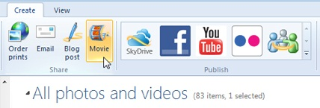
Select photos and videos in Photo Gallery to import into Movie Maker.

Edit your movies
Using the video editing features in Windows Live Movie Maker, you can make your movie look the way you want it to.

Add a video
Get started with making a movie and editing it by first adding any videos that you want to use into Movie Maker.
On the Home tab, in the Add group, click Add videos and photos. Hold down the Ctrl key and click the videos you want to use, and then click Open.

Trim video
To trim the beginning or end of a video clip so only the part of the video you want appears in your final movie, click the video you want to trim, and then drag the playback indicator on the storyboard to the point where you want the video to start or stop playing in your movie. Do one of the following:
- To set a new start point, under Video Tools, on the Edit tab, in the Editing group, click Set start point.
- To set a new end point, under Video Tools, on the Edit tab, in the Editing group, click Set end point.

Split a video
You can split a video into two smaller items and then continue editing. For example, after splitting a video, you can move one video in front of the other to change the order in which the videos play in your movie.
To split a video into two items, click the video, and then drag the playback indicator to the point where you want to split the video. Under Video Tools, on the Edit tab, in the Editing group, click Split.

Speed up or slow down a video
You can change the speed of your video in Movie Maker to make the video play faster or slower in your movie.
To change the speed of a video, click the video. Next, under Video Tools, on the Edit tab, in the Adjust group, click the Speed list, and then click a speed (depending on how much you want to speed the video up or slow it down).

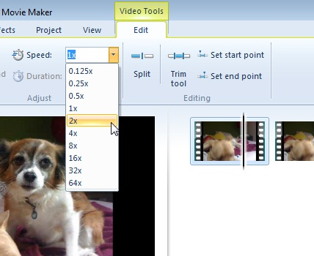

Adjust the video speed in your movie.

Edit the audio
Get great sound in your movie by using the audio editing tools in Movie Maker. Make your finished movie feel polished and professional by adding a soundtrack and using the editing features to adjust the volume, fade music in or out, and more.
Add music
You can add music that plays during your movie. After you add music, you can edit it so it plays how you want in your movie.
On the Home tab, in the Add group, click Add music. Click the music file you want to use, and then click Open.

Fade music in or out
Make the audio fade in nicely at the beginning and fade out smoothly at the end to make a movie that looks and sounds professional.
To make the music fade in or out, click the music. Then, under Music Tools, on the Options tab, in the Audio group, do one or both of the following:
- To make the music fade in, click the Fade in list, and then click the speed for the music to fade in.
- To make the music fade out, click the Fade out list, and then click the speed for the music to fade out.

Change the start or end point of the music
Trim the beginning or end of the music, so only the part of the song that you want plays in your final movie.
To trim the beginning or end of the music, click the music, and then drag the playback indicator on the storyboard to the point in the music where you want it to start or stop playing in your movie. Do one of the following:
- To set a new start point for the music to start playing at the current point, under Music Tools, on the Options tab, in the Editing group, click Set start point.
- To set a new end point so the music stops playing at the current point, under Music Tools, on the Options tab, in the Editing group, click Set end point.

Change the audio volume
You can change the volume of a music item or the audio in a video. This way, regardless of the audio or music that's playing, it sounds just right in your movie.
To change the volume of a music item, click the music. Under Music Tools, on the Options tab, in the Audio group, click Music volume, and then move the slider left to lower the volume or right to increase it.
To change the volume of the audio in a video, click the video. Under Video Tools, on the Edit tab, in the Audio group, click Video volume, and then move the slider left to lower the volume or right to increase it.

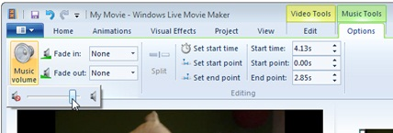

Change the volume in your movie to make it sound just right.

Choose a theme
Use AutoMovie themes to make a great-looking movie in just a few clicks in Windows Live Movie Maker. Just pick your photos, videos, and a theme, and then the transitions and effects are added for you.
Add photos and videos
On the Home tab, in the Add group, click Add videos and photos. Hold down the Ctrl key and click the photos and videos you want to use, and then click Open.

Add music
On the Home tab, in the Add group, click Add music. Click the music file you want to use, and then click Open.

Choose an AutoMovie theme
On the Home tab, in the AutoMovie themes group, click the theme you want to use. Movie Maker automatically adds titles, credits, transitions, effects, and more for you.
You can continue editing as you normally would, or just save your movie.

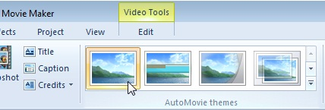

Choose from several different AutoMovie themes to get the look you want for your movie.

Share on the web
With Windows Live Movie Maker, you can quickly publish your movie to popular websites, and then share your movie with friends, family, or the whole world.
Add photos and videos
On the Home tab, in the Add group, click Add videos and photos. Hold down the Ctrl key and click the photos and videos you want to use, and then click Open.

Edit your project
Edit your project so it appears how you want. This includes adding any music, titles, effects, and transitions, or making other edits that you want.

When you are finished editing your project, MAKE SURE YOU SAVE IT AS A MOVIE!!
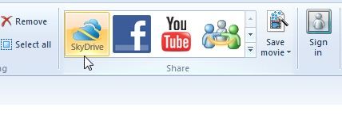
Click Save Movie, click Save to Computer.

** Note: When using headphones to edit, make sure you plug your headphones in first, then open Movie Maker Live. Otherwise, you won’t be able to hear your video clips. **

