How to use Audacity
Click start >>
- Open the "Audacity" program.
Ads by Google
Download Google Chrome
A free browser that lets you do more of what you like on the web
www.google.com/chrome
- 2
Make sure "Microphone" is selected in the top right-hand corner.
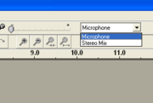
Select "Microphone"
- 3
Click on the red circle, which will start recording, and speak into your microphone. If it doesn't look like anything is recording, make sure that you increase the dial next to the microphone icon. Your voice will appear as a long jagged line, but it may look more like a series of blue shapes.
Record
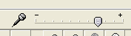
Adjust this to make the microphone more or less sensitive to your voice
- 4
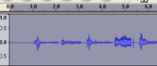
Selected Audio
Place your cursor at the beginning of the audio and click and drag towards the right to select all of the sound.
- 5
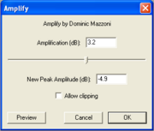
Adjust the amplitude
Go to "Effect" > Amplify to adjust the amplitude of your sound (i.e. loudness). If you click OK without adjusting anything, then it will automatically make your sound as loud as possible before clipping occurs (where some sound is cut off, and it will lose quality). You may not want it this loud, though, so you can adjust it to any volume. Setting it to a negative number will make it quieter.
- 6
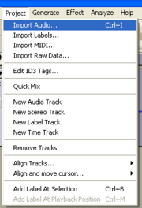
Import background music
Import some background music by going to "Project" > Import Audio and double clicking on selected music.
- 7
Edit the background to desired amplitude (see step 5).
- 8
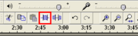
Trim outside selection
Optional: Select the part of the background music you want to have under your voice, as it will likely be too long. Leave some extra to fade in and out. Then click the button shown in the image that will trim the outside selection.
- 9
Select the icon for the Timeshift Tool (double-headed arrow), which will allow you to move around your sound. Align your voice with the background music.
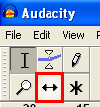
Icon for the Timeshift tool
- 10
Click back on the Selection Tool, which looks like an I.
- 11
Select a small section at the begining of your background music.
- 12
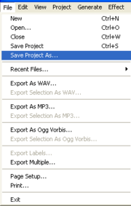
A screenshot showing the beginning section selected and how to fade in.
Click on "Effect" > Fade in, to fade in the music.
- 13
Select a small section at the end and then go to "Effect" > Fade out.
- 14
Experiment with other effects on the music and your voice. Continue with the steps when you are happy with what you have produced.
- 15
Go to "File" > Save Project As to save your work. Type in a filename and click Save. This is the version you will open in order to edit your project if you wish.
- 16
Go to "File" > Export... or Export As MP3 (depending on the version of Audacity) and save similarly to the previous step. This is a compressed version you can use on Web sites or other applications.

