Getting Started with Kindle Touch
Before you start using your Kindle Touch, you'll want to connect your Kindle Touch wirelessly, register your Kindle Touch, and set up your 1-Click payment method so you can start shopping in the Kindle Store.

1. Get Connected
Kindle Touch comes in two versions: Wi-Fi (your Kindle Touch can only connect to Wi-Fi networks) and Free 3G + Wi-Fi (your Kindle Touch 3G can connect to Free 3G or to Wi-Fi networks).
(Which device do I have?)
Video: Connecting Your Kindle Touch to Wi-Fi

Tip: Make sure your Kindle Touch is fully charged before attempting to connect to Wi-Fi.

Connecting via Wi-Fi
Your Kindle Touch can connect wirelessly through your home Wi-Fi network, or places that offer Wi-Fi access, such as a hotel or your favorite cafe. Your Kindle Touch automatically detects nearby Wi-Fi networks that broadcast their network name.
(What is Wi-Fi?)
- From the Home screen, tap Menu.  - Tap Settings, then Wi-Fi Networks  - You'll see a list of detected Wi-Fi networks. You may have to wait a moment as your Kindle Touch detects networks in range.  - Tap the name of the network you wish to join. If necessary, enter the Wi-Fi network password. The password is the one used to set up the Wi-Fi network, not your Amazon account password. If you don't know this password, please contact the person who set up the Wi-Fi network. | 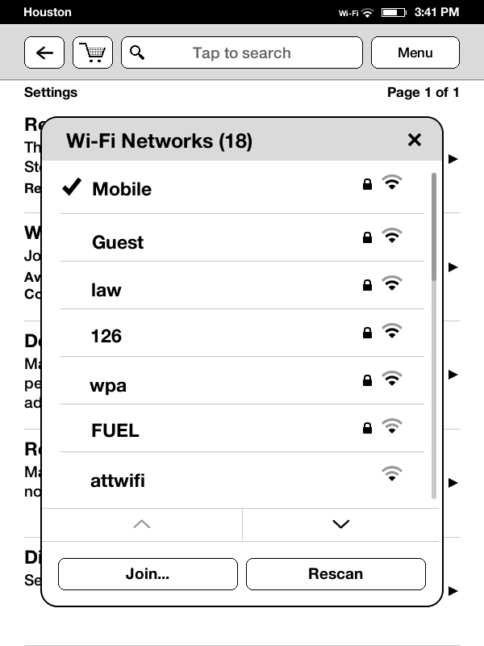
Tip: Learn more about using the onscreen keyboard on your Kindle Touch.
Once you have successfully connected to a Wi-Fi network, your Kindle Touch will automatically connect to it when it detects a signal from that network.
Connecting with Free 3G
If your Kindle Touch includes Free 3G, wireless connectivity is automatic. If you see a 3G network indicator (3G, EDGE, or GPRS) in the upper right corner of your screen, your Kindle Touch is already connected wirelessly.
Use a Wi-Fi connection for faster downloads.
Having difficulty connecting? Try our wireless troubleshooting steps.
Tip: Reading with wireless turned off will help your battery last longer. Tap the Menu button from the Home screen, then select Turn Wireless Off.

2. Register Your Kindle Touch

Video: Registering Your Kindle Touch

After you've successfully connected your Kindle Touch wirelessly, register your Kindle Touch.
(Why do I need to register?)
From the Home screen, tap the Menu button. Tap Settings, then Registration.
If you already have an Amazon account: Tap this option. Enter the e-mail and password associated with your Amazon account. Tap Register. Your name will appear as the Registered User when registration is complete.
If you do not have an Amazon account: Select this option and follow the onscreen instructions to set up a new account.
You can also register your Kindle Touch online through the Manage Your Kindle page. To set up a new Amazon account or change your password, visit Amazon.com.

